
Chemistry Year 12
All you need: redox

Introduction + best advice for chemistry from my experience:
Hi my name’s Ovik Choudhury I graduated from Rossmoyne Senior High School last year (2019) with an ATAR of 99.55. I was a lazy kid so instead of doing my homework (reading chapters of Lucarelli and doing those questions which btw I never did and you shouldn’t either because they suck for test practice…best thing to do is do practice questions and memorise where marks are allocated) I tried to find the most efficient ways to do tests. What I mean by that is if you read Lucarelli and do all those practice questions you’ll know a tonne about the subject, but it doesn’t mean you’ll do well in tests (which ultimately matters at the end of the day). So instead of doing all that the best 3 advice in my opinion for getting high marks are.
- Knowing where all the marks are in a question (most important)
I’ll deal with this by giving you perfect marking key solutions and quizlets to memorise where marks are
- Fast and efficient in answering questions (second most important)
I was a reckless kid and the only time I got high marks was if I had time to check my mark and think ‘wow I’m a dumbass, let me change this’
I’ll deal with this by giving you ideal question time which accounts for giving you extra time at the end to check your work. Have at least 10 minutes after on tests and at least 20 on exams. I’ll also show you tricks to skip steps and get faster.
- Knowing what to expect and where to put your efforts into studying (very important)
I’ll deal with this by telling you all the information from importance and frequency in tests so you don’t waste effort on learning irrelevant stuff.

Also, from my experience, stinging is great you should always do it. I was reckless and have messy handwriting so I usually got like an additional 5% (up to 10% from maths subjects) from just stinging. However, this means know your stuff, so you have grounds to stinge. Don’t rely on stinging, stinging worked great for me until my WACE exams. I couldn’t stinge so I got screwed so my best advice is to have clear concise working out, for theory it’s a little different: everyone understands the concepts but can’t explain it ‘marking language’, teachers are also stingy and will pick at your work so memorise marking key phrases so they have nothing to argue against and theory questions will become your best friend.

Labels:
Need to know but around 70% won’t be asked (1000% need to know)
Will definitely be on your tests (95% chance) (definitely 100% need to know)
Will most likely be on your tests (75%) definitely need to know
Maybe (50%) you need to know
Ehh (25%) just know it, dude
Nahhh (5%) know that it exists
Nope (0%) you don’t need to know, it’s probably just context for other information
Anything above 5% you NEED to know if you want to get higher marks.
if marking key solutions are bolded those are the keywords that’ll actually get the marks the rest is to just fill in the gaps

recommendations:
finish multiple choice questions under 96 seconds per question (which is pretty kind)
Finish section 2 questions under 32 seconds per mark
Finish section 3 questions under 36 seconds per mark
Should be relatively difficult to get those but if you did, good job

In summary I’m giving you what I wish I had in year 12 and improving upon my mistakes

Notes:
What are redox reactions?
(1 mark)
Redox reactions are chemical reactions that involve the transfer of electrons

Redox

Oxidation Is Loss of electrons Reduction Is Gain of electrons
OIL RIG

So remember OILRIG
(think of reduction as reducing charge due to the gain of electrons)
In a redox reactions one reactant gets reduced and another gets oxidised simultaneously
Gets reduced (gains electrons) | Gets oxidised (loses electrons)
Oxidising agent (causes oxidation therefore gets reduced) | Reducing agent (causes reduction therefore gets oxidised)
Oxidant | Reductant

The way we know if a reaction is redox (has the transfer of electrons) is by measuring changes in
OXIDATION NUMBERS
Oxidation numbers are worth a very small percentage of exams ~2-3 marks of an exam because they are very common for multiple choice questions and is rarely seen not in multiple choice questions. 100% chance it’ll pop up in topic tests.
This is important for multiple choice questions that ask ‘which one is/isn’t a redox reaction’ and general questions asking to find oxidation numbers.
Oxidation numbers are sort of like charges/valencies.
They are multiplied by the number of the element in the compound
They are added with the oxidation numbers of other elements
If a substance increases oxidation number (from reactant to product), it has been oxidised (loses electrons)
If a substance decreases oxidation number, it has been reduced (where the name reduction comes from) (gains electrons)
If a substance increases oxidation numbers and decreases it’s called ‘disproportionate’ and is still a redox reaction

Oxidation number rules
- Elemental/molecules/compounds all have a total oxidation number of 0 using addition
Ca_{(s)} =0,
O₂ =0
both oxygens have a 0 giving a total 0
CH₄ =0
all oxidation numbers add up to give a total of 0
- Atomic charge = oxidation number
SO₄²⁻ has a total oxidation number of -2, however oxidation numbers of oxygen and Sulfur might be different
Mg²⁺ = 2+
NaCl=0,
BUT since it’s ionic bonding, NaCl is the same as Na⁺ & Cl⁻ therefore individually has oxidation numbers of +1 and -1 respectively. But together, since you add them will be 0
- Hydrogen has 1 in compounds except for metal hydrides( =-1)
H₂CO₃=0, CaH₂, NaH

- Oxygen = -2 in compounds except for peroxides (=-1) and except for F₂O (=2)
H₂O, NO₃⁻=-1 (O number is charge)

Questions: do them in 96 seconds
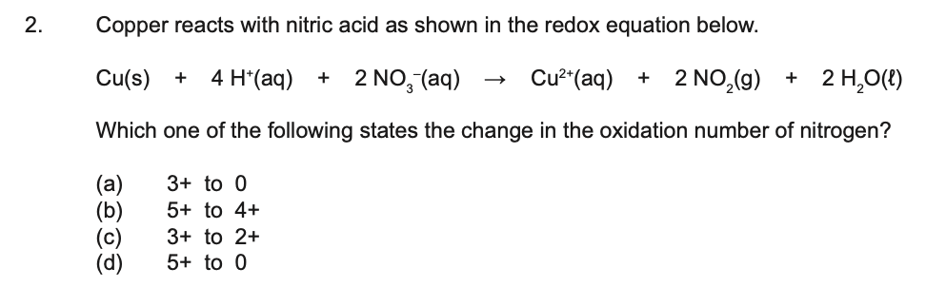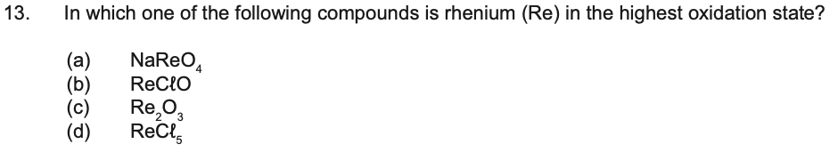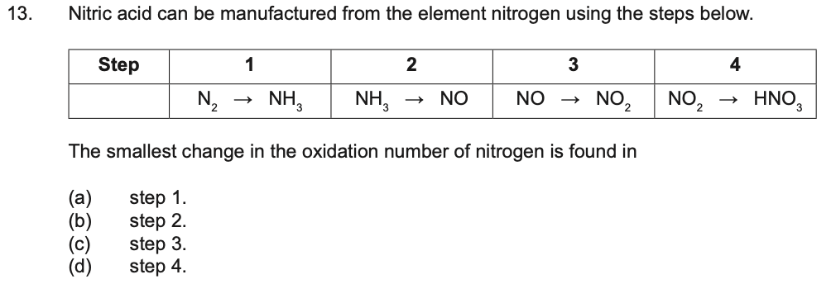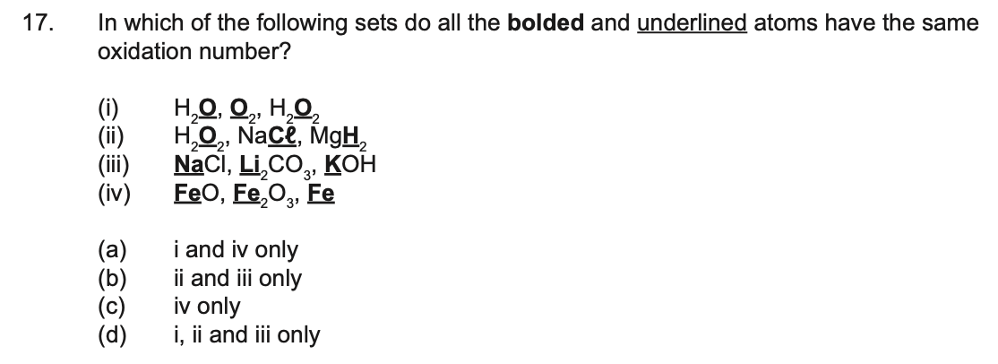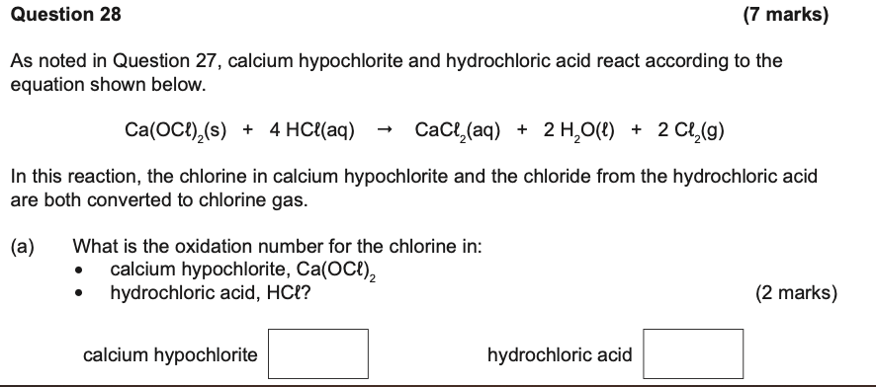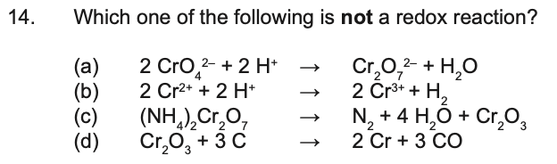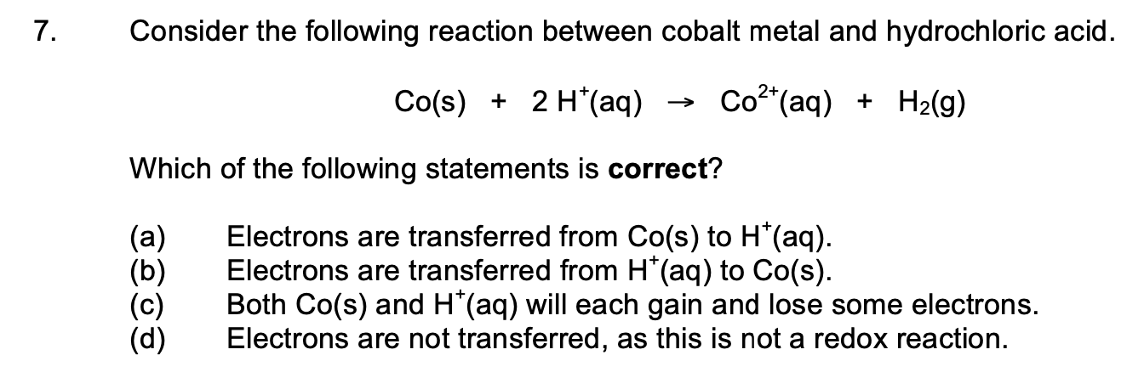a
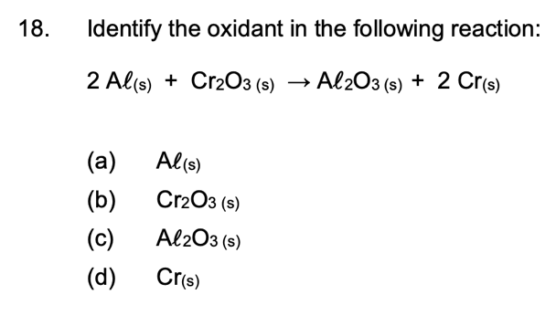b

Half equations
These questions are relatively important, more than oxidation numbers and will 100% be in topic tests. They are very easy to make mistakes in. However, they are small questions, not worth a lot of marks but can be intro questions that lead to more questions. Most likely seen in section 2 worth around 6 marks but can lead onto other questions.
They are used when you have a reactant that turned into a product where you don’t know how to balance or add other reactants. Therefore, to balance you need to follow 5 steps
There are 2 marks allocated for these questions
1 for correct reactants and products
1 for correct balancing
Don’t forget states of matter but sometimes markers are lenient on this
Electrons don’t have states
Have single arrows

Question:
Lead Oxide turns into Lead ions, what is the half equation of the reaction (2 Marks)
(70 seconds)
- Identify the product and the reactant
PbO₂ _{(s)} is the reactant therefore goes on LHS and Pb²⁺ is the product (given) therefore foes to RHS
PbO_{2(s)} Pb²⁺_{(aq)}

- Balance ‘stem’ elements, basically anything that’s not Hydrogen or Oxygen which in this case is Pb
Make sure there’s the same amount of Pb on each side in this case there is
PbO_{2(s)} Pb²⁺_{(aq)}

- Balance Oxygen atoms with water molecules (liquid)
There’s 2 on the LHS and 0 on the RHS, therefore must add 2 water molecules to the RHS
PbO_{2(s)} Pb²⁺_{(aq)}+2 H₂O_{(l)}

- Balance Hydrogen atoms with H⁺ ions
There’s 0 on the LHS and 4 on the RHS therefore must add 4 H⁺ (aqueous) ions to LHS
4 H⁺_{(aq)} + PbO_{2(s)} Pb²⁺_{(aq)}+2 H₂O_{(l)}

- Balance charge with electrons
There’s 4+ on the LHS and 2+ on the RHS therefore must add 2 electrons (e⁻¹) to the LHS to make 4+-2=+2=RHS

2 e⁻¹ + 4 H⁺_{(aq)} + PbO_{2(s)} Pb²⁺_{(aq)}+2 H₂O_{(l)}
check on your data sheet if it’s correct
quick tip: make the reactants and products close on either side of the arrow in the middle of the page, so you don’t have to estimate the space you need to add other reactants or products

Since the electrons are on the LHS, the reactants are gaining electrons and this is therefore a ‘reduction half equation’
If it was on the RHS it’d be an ‘oxidation half equation’

Combining half equations
Let’s say we want to combine (two half equations into a full equation)

2 e⁻¹ + 4 H⁺_{(aq)} + PbO_{2(s)} Pb²⁺_{(aq)}+2 H₂O_{(l)}
And
2 Cr³⁺_{(aq)} + 7 H₂O_{(l)} Cr₂O₇²⁻_{(aq)} + 14 H⁺_{(aq)} + 6 e⁻¹

Here are the 4 steps needed
Which one’s reduction half equation, which one’s oxidation?

- Multiply each half equation by an integer such that the electrons are the same on each equation and then cancel them out
First half equation has 2 electrons, second one has 6. To make them the same, we multiply the first half equation by 3 to be 6 too

6 e⁻¹ + 12 H⁺_{(aq)} + 3 PbO_{2(s)} 3 Pb²⁺_{(aq)}+6 H₂O_{(l)}
And
2 Cr³⁺_{(aq)} + 7 H₂O_{(l)} Cr₂O₇²⁻_{(aq)} + 14 H⁺_{(aq)} + 6 e⁻¹

- Add the reactants together on the LHS and the products together on the RHS

- H⁺_{(aq)} + 3 PbO_{2(s)} + 2 Cr³⁺_{(aq)} + 7 H₂O_{(l)} 3 Pb²⁺_{(aq)}+6 H₂O_{(l)} + Cr₂O₇²⁻_{(aq)} + 14 H⁺_{(aq)}

- Cancel out hydrogen ions (H⁺)
There’s 12 Hydrogens on the LHS and 14 on the RHS, to cancel take 12 Hydrogens from both sides which leaves 2 on the RHS.
3 PbO_{2(s)} + 2 Cr³⁺_{(aq)} + 7 H₂O_{(l)} 3 Pb²⁺_{(aq)}+6 H₂O_{(l)} + Cr₂O₇²⁻_{(aq)} + 2 H⁺_{(aq)}

- Cancel out water (H₂O)
There’s 7 water molecules on the LHS and 6 on the RHS. Take 6 from both sides leaving 1 water molecule left on the LHS
3 PbO_{2(s)} + 2 Cr³⁺_{(aq)} + H₂O_{(l)} 3 Pb²⁺_{(aq)} + Cr₂O₇²⁻_{(aq)} + 2 H⁺_{(aq)}

This is your final answer, steps 3 and 4 are interchangeable, sometimes states will not be required but don’t take chances

Questions: do in 3 mins and 12 seconds
These questions are very common usually 1 per test. 2 marks each section.
1 mark correct balancing
1 mark correct formula
Always have states when possible, single arrow, get the combination of both half equations right because it’s the hardest step
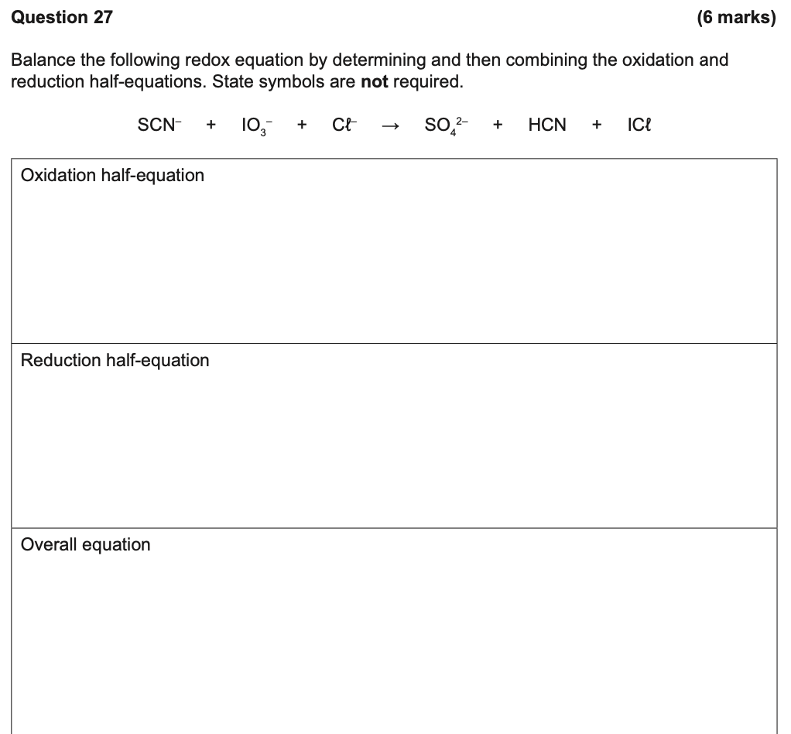
This is the second type of half equation question you’ll get. Use both methods to find the overall equation.

Ovik tips:
for SCN⁻ SO₄²⁻ +HCN after identifying the reactants, the RHS has more oxygen atoms and therefore more electrons will be on that side, therefore will be losing electrons therefore will be oxidation

IO3⁻+Cl⁻ to ICl has more oxygen atoms on LHS, more electrons on LHS reduction

This is because (for reduction), Oxygen has to be balance with H₂O on the RHS, the hydrogens have to balanced by H⁺ on the LHS and since it adds positive charges it must be negated by electrons on the LHS to make charges the same on each side. Since electrons on LHS, electrons gained reduction

Expected voltages
Theses questions are very common in multiple choice questions asking for expected voltages or if a reaction is spontaneous. Worth very few marks mostly in second section.
Expected voltages are the expected voltages of electrochemical cells (galvanic and electrolytic, where electrolytic cells will have negative voltages, we’ll cover later) under standard conditions which are 1molL⁻¹ solution, 100kPa, 25ºC and aqueous solutions, if the conditions are different the voltage will be different. You can find the expect voltages of half equations on the data sheet on the standard reduction potential table. To find the overall expected voltage you need to do Eº_{total}=Eº_{oxidation}+Eº_{reduction}. If the expected voltage is above 0, the redox reaction is spontaneous, if the expected voltage is 0 or negative it is non-spontaneous. Expected voltage could be thought of a measure of how much the reactants want to gain or lose electrons:
F_{2 (g)}+ 2 e⁻ 2 F⁻_{(aq)} Eº_{total}=+2.89V
means: F_{2 (g)} really wants to gain electrons to reduce

expected voltage can be reversed going from the other direction
2 F⁻_{(aq)} F_{2 (g)}+ 2 e⁻ Eº_{total}=-2.89V
Means: F⁻ really wants to keep its electrons

Eº_{total}=Eº_{oxidation}+Eº_{reduction}
If you had two half equations:
- F_{2 (g)}+ 2 e⁻ 2 F⁻_{(aq)} 2.89V
- Au_{(s)} 3 e⁻ + Au³⁺_{(aq)} -1.50V

Eº_{total}=2.89+-1.50=1.39V and therefore is a spontaneous reaction

Fast way to find if the expected voltage is positive or negative with relative magnitude

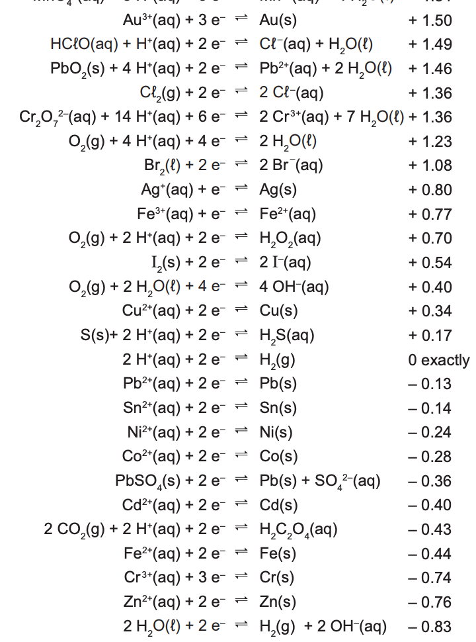
Reaction 1 is spontaneous (positive expected voltage=1.36+-0.80=0.56V) since the gradient is negative. Reaction 2 is also spontaneous however has a higher expected voltage (1.36+-0.54=0.82V) because the gradient is even more negative. Reaction 3 is non spontaneous (-0.34+-0.13=-0.47V
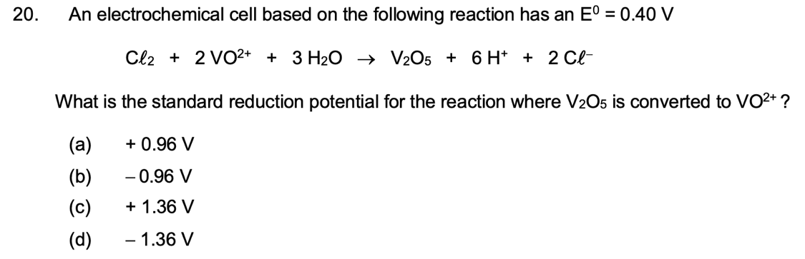a

Metal displacement/halogen displacement:
Metal displacement reactions occur when a solid metal oxidises to turn into a cation whilst a cation reduces to form into a solid effectively displacing each other. Sometimes the cation could be Hydrogen ions which reduce to form hydrogen gas. Metal displacement questions usually occur in multiple choice questions.
However, could also occur in galvanic cells as a trick question which happened to us in our topic test. They’re not worth many marks.

Stronger reducing agents like to get oxidised so they will have the highest oxidation expected voltage will be at bottom right of standard reduction potential table
Stronger oxidising agents like to get reduced so they will have the highest reduction expected voltage will be at top left of standard reduction potential table

Keep in mind bromine water has Br₂ and chlorine water is Cl₂ (both aqueous) if they are a product they don’t bubble
`
Consider piece of tin metal dipped in a copper sulphate solution
- Will metal displacement occur? 1 mark
- What is the expected voltage in standard conditions? 1 mark
- What are the respective half equations 2 marks
1 mark per half equation
Lose one mark for double arrows
Use single arrows

- What is the total equation 2 marks
1 mark Correct reactants and products
1 mark Correct balancing
Use single arrow

What are the observations recorded (4 marks)
1 mark stating metal displacement will occur
1 mark Description of action stating colour
1 mark changes in solid
1 mark changes in solution colour (before and after)

- Find reactants on data sheet
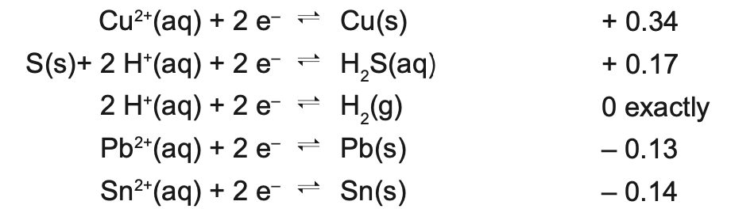
Since the expected voltage is positive, spontaneous reaction,
1 mark - metal displacement will occur as expected voltage is positive

- Find expected Voltage:
Expected voltage will be 0.34+0.14=0.48V therefore spontaneous and will displace eachother. Or use negative gradient rule
1 mark - 0.34+0.14=0.48V

- Find half equations
Copy from data sheet
Reduction: Cu²⁺_{(aq)} + 2 e⁻ Cu_{(s)}
Oxidation: Sn_{(s)} Sn²⁺_{(aq)} + 2 e⁻
- Find full equation
Sn_{(s)} + Cu²⁺_{(aq)} Sn²⁺_{(aq)} + Cu_{(s)}

- Observations
Metal displacement will occur expected voltage is positive
Silvery grey solid placed in blue solution
Salmon pink solid deposits on solid
Surrounding blue solution decolourises

Halogen displacement is like the same thing:
Question: Chlorine gas is bubbled through a solution of potassium bromide

- Will halogen displacement occur? 1 mark
- What is the expected voltage in standard conditions? 1 mark
- What are the respective half equations 2 marks
1 mark per half equation
Lose one mark for double arrows
Use single arrows

- What is the total equation 2 marks
1 mark Correct reactants and products
1 mark Correct balancing
Use single arrow

What are the observations recorded 3 marks
1 mark saying halogen displacement will occur
1 mark Description of action stating colour
1 mark changes in solution (before and after)

- Find reactants on data sheet
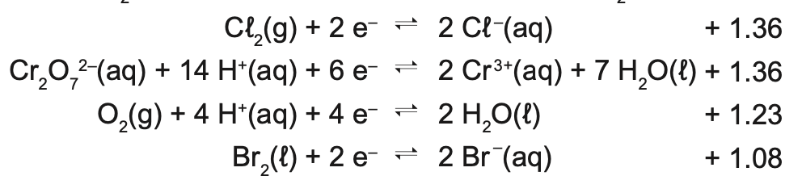

Expected voltage is positive, therefore halogen displacement will occur

- Find expected voltage:

- Find half equations
Copy from data sheet

- Find full equation

- Observations

Halogen displacement will occur as expected voltage is positive
Greenish-yellow gas bubbled through colourless solution
Colourless solution turns orange

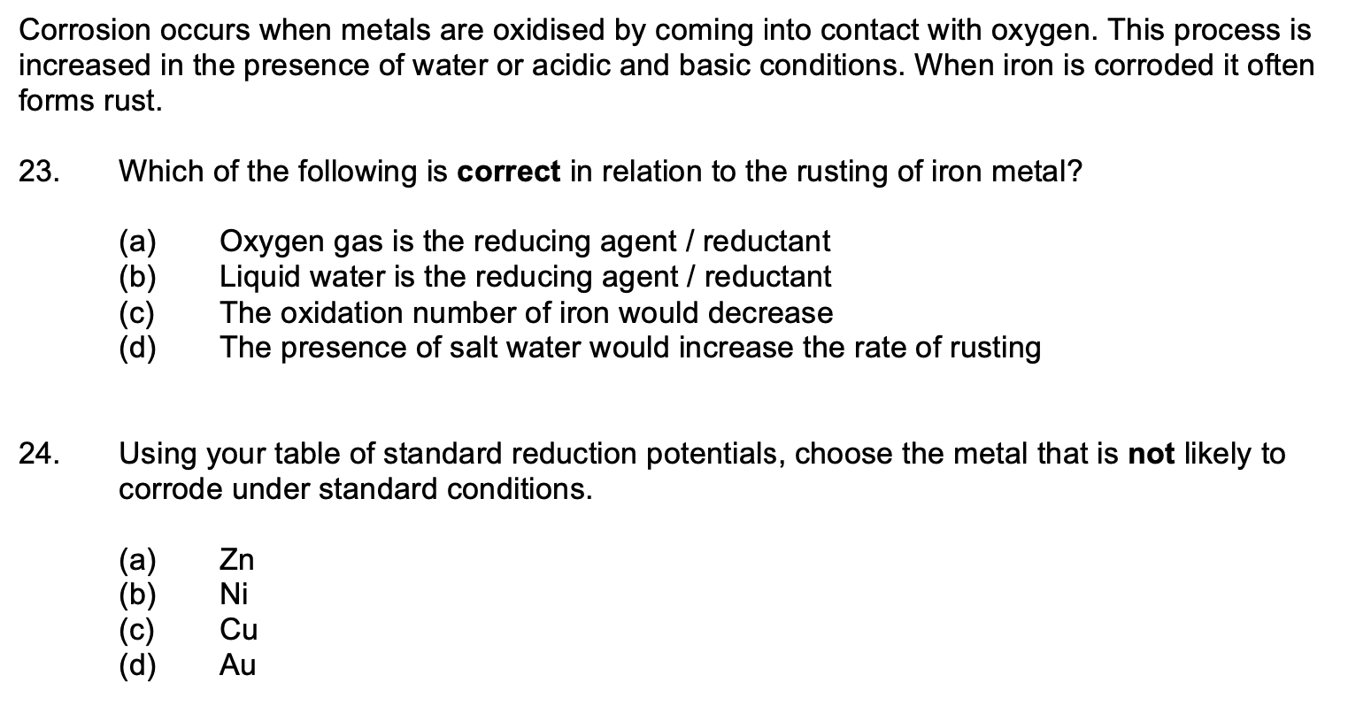d,d

What’s a stronger reducing agent magnesium or tin? 2 marks
1 mark – magnesium, Eº value of oxidation is higher for magnesium than tin (2.36 to 0.14V)
1 mark – higher tendancy to oxidise therefore stronger reducing agent

Note: nowadays you don’t get a mark for stating an option out of 2, marks are allocated for explanation

Chlorine water added to zinc bromide solution, describe any observations 3 marks
1 mark - Halogen displacement will occur
1 mark – pale yellow and colourless solution mixes to produce orange solution

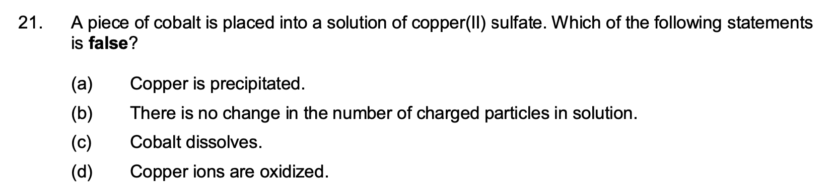d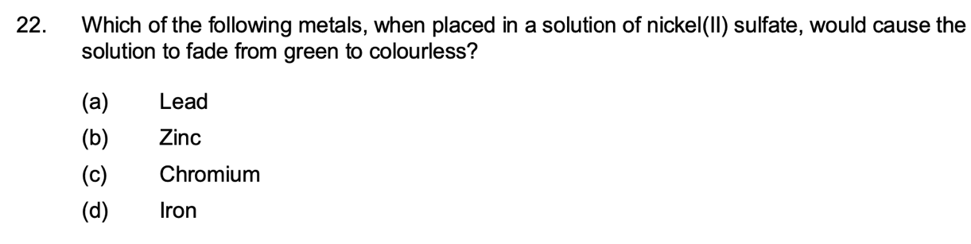b

Galvanic cells/voltaic
Galvanic cells look like this:
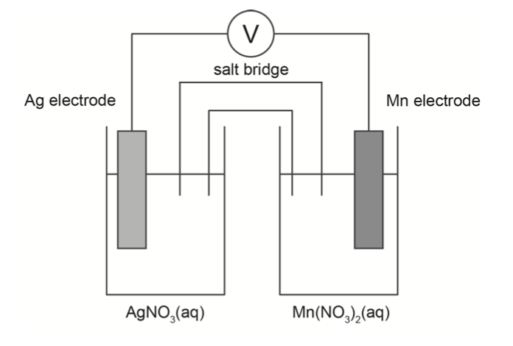
They always have separate cells(beakers) in two or more beakers. They turn chemical energy into electrical energy. They use a spontaneous redox reaction separated so that electrons are forced to go through external wire. They are more common in tests than electrolytic cells.

Components:
- electrolyte solution (1 mark for explanation)
(has charged particles that carry current and complete circuit)
- Salt bridge: (1 mark each for explanation)
- Separates two cells so that reactants don’t have contact therefore electrons will directly transfer instead of going through external wire (main)
has unreactive ions to carry charge and complete circuit usually KNO₃, NaNO₃
takes no part in chemical reactions
Prevents build up of charges
It is non optional for galvanic cells
Allows ions to pass between the two half cells
- Electrodes provide a place for transfer of electrons and has to conduct electricity
- Wire: external wire for electrons to pass through

The possible questions for galvanic cells are.

- Name the anode and cathode (1 mark)
to do this you must remember two things
ANOX = Anode is Oxidation

REDCAT = Reduction is Cathode
This holds true for both electrolytic and galvanic cells

- First step is to find all possible reactants

H₂O, Mn²⁺_{(aq)}, Mn_{(s)}, Ag¹⁺_{(aq)}, Ag_{(s)}
Consider ions in solution, electrodes, if gases are being bubbled, water
NOTE: water will always be a possible reactant for redox but is very rare in tests
(Still check).
Note: Nitrate is not in the reduction table so never have sulphates, nitrates, carbonates, phosphates

- Use negative gradient rule to find the redox reaction with the highest expected voltage (future Ovik will explain)
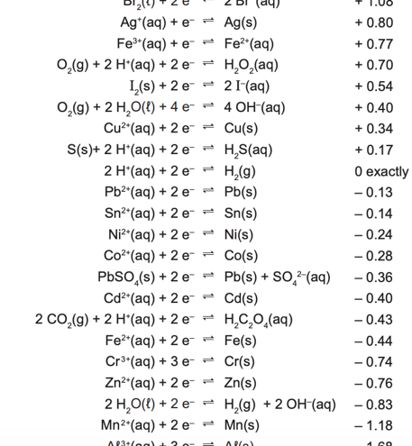
Since we see Ag reduces and Mn oxidises, Ag is the cathode and Mn is the anode

Since Mn is oxidising the right electrode will be the anode. Since silver is reducing the left electrode will be the cathode.
Ovik tip: find all reactants on the standard reduction potential table and choose the highest on the left side (reduction) and the lowest on the rhs (oxidation) this will give you the reaction with the highest expected voltage

- What is the expected voltage? (1 mark)
0.8+1.18=1.98V

- What is the polarity of the cathode and anode? (1 mark)
For polarity you need to think of the galvanic cell as a battery. Since Oxidation is loss of electrons, electrons will come out of the ANODE giving it a negative polarity which makes the cathode positive.
FOR GALVANIC CELLS
ANODE IS NEGATIVE, CATHODE IS POSITIVE
Keep this in mind since it’s opposite for electrolytic cells

- What is the anode half equation? (1 mark)
Anode half equation is oxidation of Mn
Sourced from data sheet they are not reversible
Mn_{(s)} Mn²⁺_{(aq)} + 2 e⁻

- What is the cathode half equation? (1 mark)
Cathode is reduction of Ag
Ag⁺_{(s)} + e⁻ Ag_{(s)}

- What is the full equation?
Combine two half equations and cancel electrons
Mn_{(s)} + 2 Ag⁺_{(s)} 2 Ag_{(s)} + Mn²⁺_{(aq)}

- Which way does the electrons go? (1 mark)
Since oxidation at anode is loss of electrons and reduction at cathode is gain of electrons. Cathode needs electrons therefore
Electrons go towards cathode this stands true for both galvanic and electrolytic cells

- Which ways do the ions go in solution (1 marks)
Since at cathode, electrons are received for reduction positively charged ions go to the cathode and therefore negative charges go to anode
Cations go to cathode, anions go to anode true for both galvanic and electrolytic
- Observations (4 marks)
1 mark change in anode electrode
1 mark change in anode solution (before and after)
1 mark change in cathode electrode
1 mark change in cathode solution (before and after)

Mn electrode loses mass/dissolves.
Surrounding solutions turns more pale pink
Silvery-grey deposits on Ag electrode, gains mass.
Surrounding Solution remains colourless

Metal: silvery-grey
Gas: odourless, colourless

Rules:
For electrode, possible changes :
___solid deposits on electrode, ________ (usually colourless odourless gas) bubbles from the electrode, the electrode dissolves, the electrode gains mass,

For solution, possible changes:
____ solution decolourises, _____ coloured solution changes to _____, solution remains colourless

Rarely: there is no observable reaction

Most likely theory questions on galvanic cells:

Why does the rate of production of electrical current from this cell decrease as it operates? (3 marks)
1 mark- concentration of reactants decreases due to reaction
1 mark – frequency of successful collisions decrease (decrease rate of reaction)
1 mark - decreases electrical current

Why are beakers separated? (2 marks)
1 mark - if in contact electrons will be directly transferred
1 mark – electrons won’t go through external pathway, therefore no current

Why are salt bridges used? (3 marks)
1 mark- Prevents direct contact of reactants
1 mark- allows ions to pass, carry charge, complete circuit
1 mark- prevents build up of charges

Role of hydrogen half cell in voltages (2 marks)
1 mark- reactants expected voltages determined relative to hydrogen half cell
1 mark- which is assigned Eº of 0V = reference cell

Other reactants are measured anodic in comparison to the hydrogen half cell

Limitations of standard reduction table (choose a few) , must be standard conditions therefore:
Concentration is 1 molL⁻¹
Temperature is 25ºC
Pressure is 100kPa
Applies only to aqueous solutions
Gives no indication of reaction rates or activation energies

Why is the expected voltage different than predicted? 2 marks
Choose 2:
1 mark - cell is not under standard conditions (main)
1 mark – some of the potential could be turned into heat
1 mark – drop in voltage due to resistance

Another reactant is added to the beaker which either reduces or increases the concentration of a reactant (usually uses silver ions added which precipitates to form AgCl)
What happens to the current/voltage? Answer using collision theory
3 marks
1 mark concentration of chlorine ions drop due to precipitation (AgCl)
1 mark this decreases frequency of successful collisions (reaction rate)
1 mark decreases voltage/current

What’s a suitable electrolyte in salt bridges, why is Na₂CO₃ not a good option 5 marks
1 mark – potassium nitrate is a good electrolyte
1 mark – it’s unreactive
1 mark – Na₂CO₃ is very reactive (CO₃⁻ is insoluble with a lot of cations check solubility sheet)
1 mark – can clog up salt bridge,
1 mark - can’t complete circuit

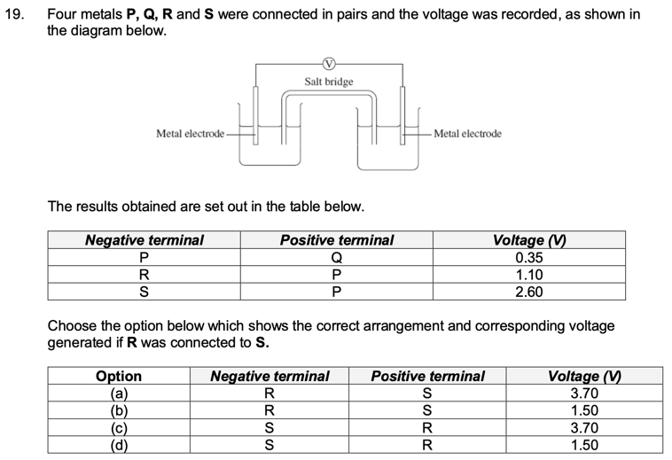d

Electrolytic cells
Electrolytic cells turn electrical energy into potential energy. Uses an Emf source to force electrons to complete a non spontaneous redox reaction. DC power provides energy or oxidation and reduction.
Cells look like this
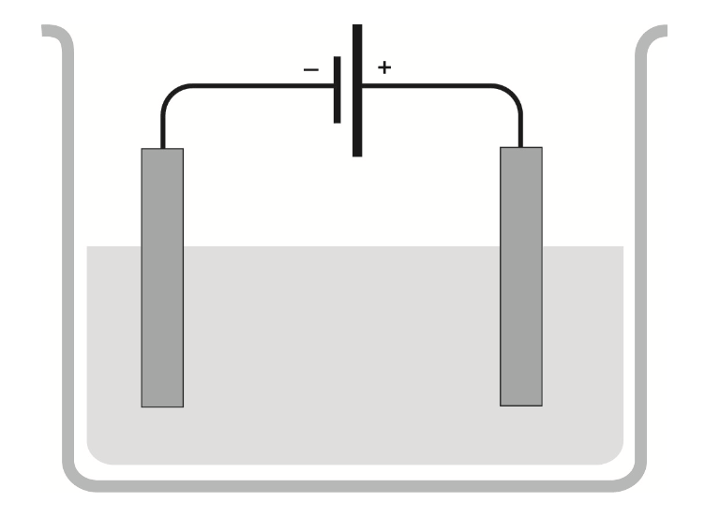
A quantity of pure chromium chloride (CrCℓ₃) is melted and placed in a heatproof vessel. Two inert electrodes are inserted as shown below and a current flow through the molten liquid. Complete and label the diagram below, showing the:
Label: (7 marks)
anode and
its polarity
cathode and
its polarity
direction of electrons
ions present and the direction

find anode and cathode: cathode is where electrons go into (left) as reduction needs electrons, anode is the other one or where electrons come out of (right)
find polarity, electrons go into cathode making it negative, anode is positive
direction, always electrons go towards cathode in wire
ions present (find ions in solution)
direction (cations to cathode, anions to anode)

- Write the oxidation half-equation. (2 marks)

- Write the reduction half-equation. (2 marks)

- Write the overall redox equation. (2 marks)

- Indicate (by circling) which process occurs at the electrode that is connected to the negative terminal. (1 mark)

oxidation reduction redox

- What is the minimum voltage required for the redox reaction to occur (1 mark)
it’s the negative of the expected voltage

- What observations occur? (3 mark)
Cathodes
1 mark – silvery grey solid forms on cathode, left electrode gains mass
1 mark - surrounding pale pink colour decolourises

Anode
1 mark- greenish yellow, odourless gas bubbles from anode

Last mark would be if Cl⁻ had a colour change to clear and colourless so check

Common questions regarding comparison of galvanic cells or just electrolytic cells

Why can the electrodes both be in the same solution? 2 marks
1 mark – the expected voltage is below 0 therefore is non spontaneous
1 mark – the reactants won’t react therefore won’t need to be separated

What are the principles of electrolytic cells and why each cell produces different voltages?
1 mark- oxidation and reduction happens in different locations
1 mark- electrons must go through external wire (current
1 mark- cells have different half reaction E0 values producing different voltages
1 mark- Greater difference in E0 value of two half-reactions, greater voltage produced

Electroplating/electrorefining
Electroplating is when a solid is coated with either silver or copper in an electrolytic cell
Electro refining is when either copper or silver is purified in an electrolytic cell

Apply a small DC voltage. Connect ‘blister copper’ to anode. Copper and reactive metals in the impure metal will oxidise and turn into ions in the water. Since copper reduction half equation is the only positive expected voltage it will reduce onto the cathode either plating an object or being in a highly pure form.

They look like this
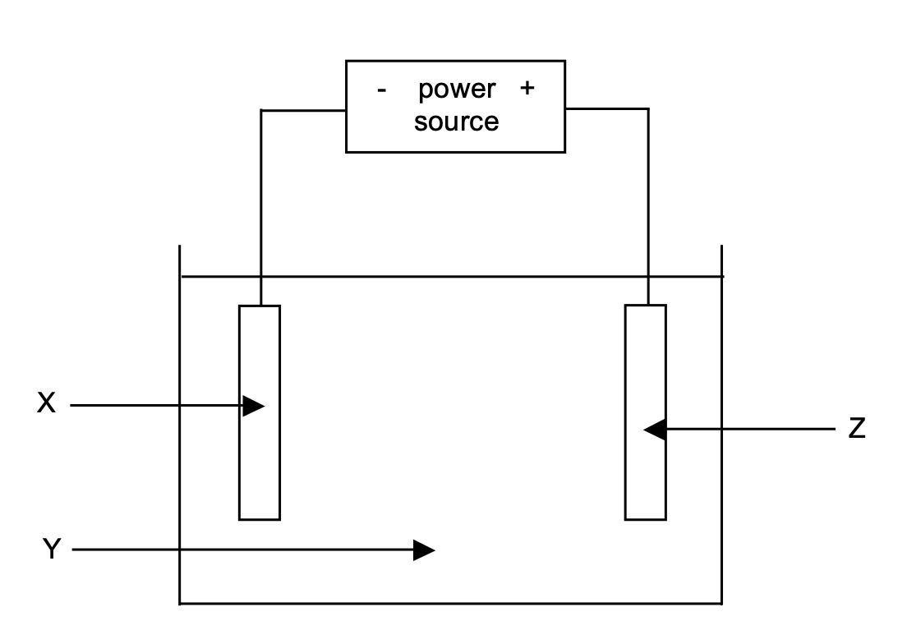
Common questions for electroplating and electrorefining
Why is power source required? (2 marks)
1 mark – cell potential is 0V
1 mark – therefore external voltage is required

Common questions for electrolytic cells:
State /similarities for galvanic cells and electrolytic cells 1 mark each 4 marks
1 mark – both have electrodes
1 mark – both have operate on potential difference
1 mark – cations go to cathode, anions go to anode
1 mark – reduction at cathode, oxidation at anode
1 mark – both are redox
1 mark – electrons flow towards cathode
1 mark – electrolyte required for both
1 mark – electrons flow on external circuit

Differences
1 mark – galvanic cells have positive cathode and negative anode, electrolytic cells have negative cathode and positive anode (important)

1 mark – galvanic cells require a salt bridge, electrolytic cells don’t
1 mark – galvanic cells require separated oxidants and reductants (similar to salt)
1 mark – galvanic cells have spontaneous reaction electrolytic cells don’t
1 mark – galvanic cells don’t require an EMF whilst electrolytic cells do (similar to spontaneous)
1 mark – galvanic is chemical to electrical, electrolytic is electrical to chemical (similar to Emf)
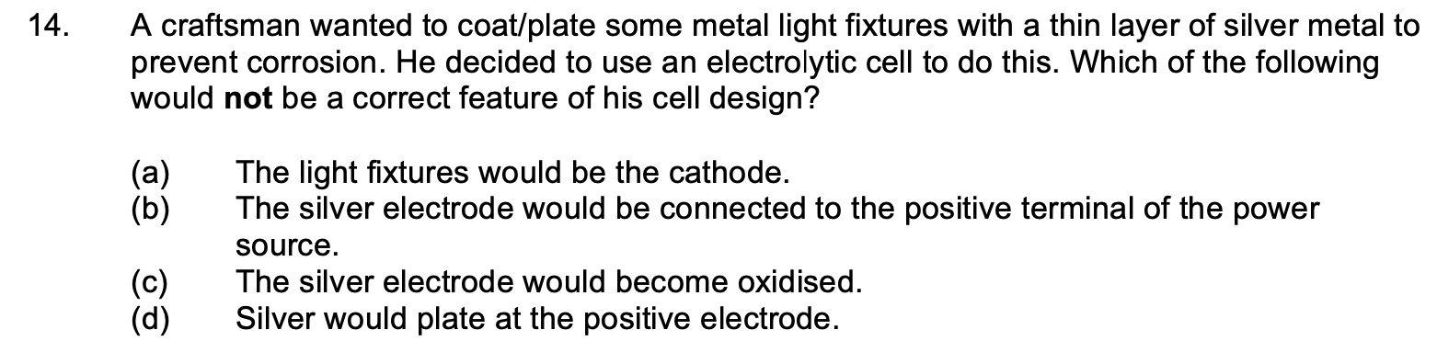d

Batteries
Batteries are galvanic cells that produce voltages. There are primary, secondary and fuel cells. Know the definition of primary and secondary, memorise the hydrogen fuel cell.

Primary cells: also called dry cells
Non rechargeable
Fixed amount of reactants
Can’t be replaced once consumed
Common one is
Zn(s) → Zn2+(aq) + 2 e–

Secondary fuel cell
Rechargeable galvanic cells (car lead acid batteries)
If you have a voltage with a current in the opposite direction of the current it recharges the battery.
They’ll become degraded after many cycles

Fuel cells
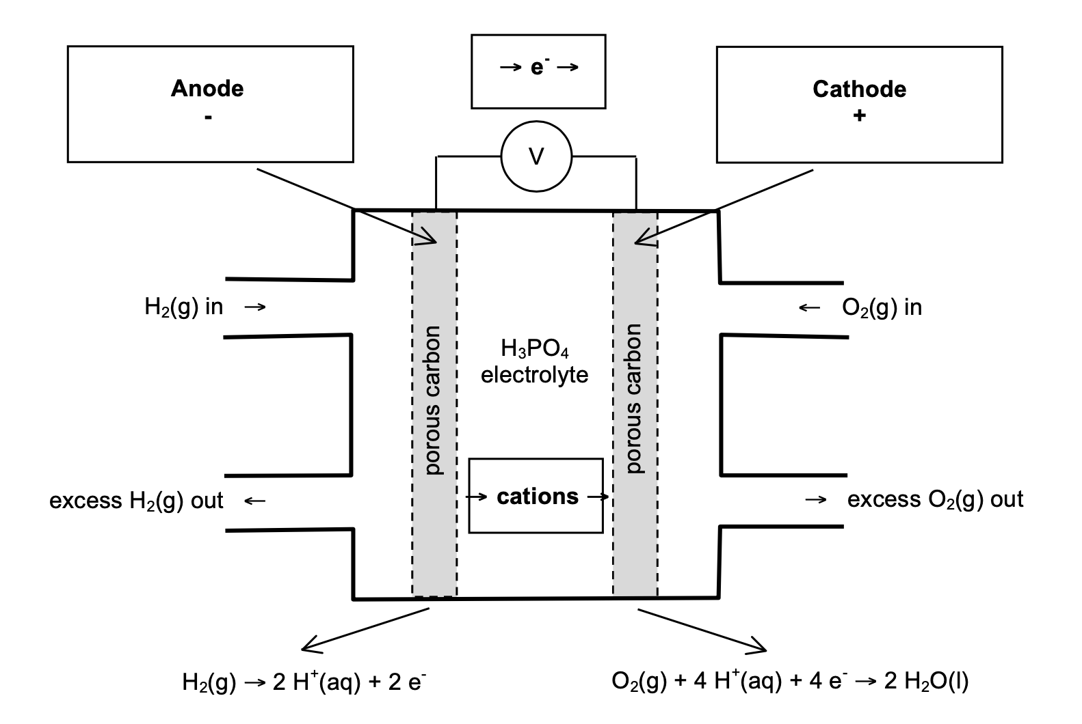
Memorise everything in this diagram specifically electron flow, anode and cathode and half equations and cation, anion flow.

Most common questions:
Explain why many consider this fuel cell to be a ‘clean’ source of energy. Use a chemical equation to support your answer. (2 marks)

1 mark - product of this cell reaction is water, harmless substance
1 mark - overall cell reaction: 2 H2 + O2 → 2 H2O

Where are reactants sourced from? 2 marks
1 mark - Oxygen from air
1 mark - Hydrogen from crude oil/steam reforming/electrolysis of water

Why is the expected voltage different than predicted? 2 marks
Choose 2:
1 mark- cell is not under standard conditions
1 mark – some of the potential could be turned into heat
1 mark – drop in voltage due to resistance
1 mark – high temperatures and extremely concentrated phosphoric acid (not standard conditions)

Why is a porous membrane used 2 marks
1 mark – used to allow ions to pass and complete circuit
1 mark – used to separate 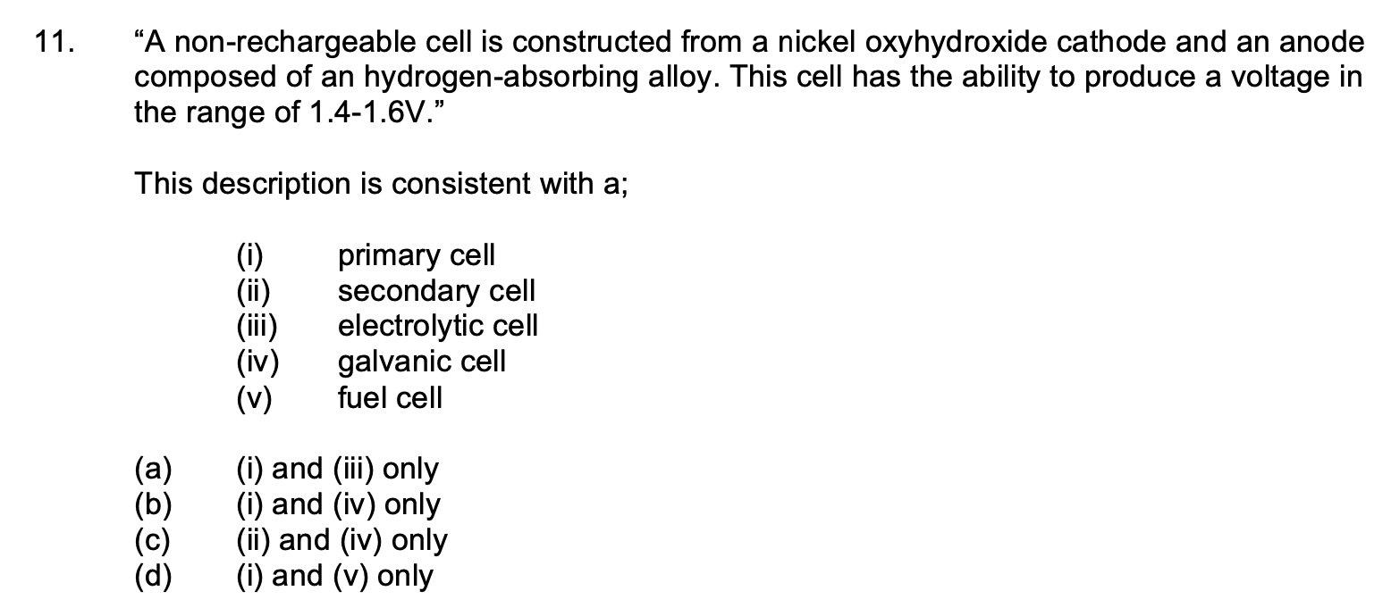b

What are some advantages of fuel cells 2 marks
Choose 2
Harmless to the atmosphere (produces water)
Oxygen is conveniently sourced
Long shelf life
Efficient
Affordable

Disadvantages:
Fossil fuels needed for hydrogen
Hydrogen sourcing is not cost efficient
Flammable (oxygen and hydrogen)
Storage for hydrogen is difficult

Goodluck on your exams

Didn’t cover but sometimes you get these types of galvanic cells (couldn’t find)

